**COMPUTER SCIENCE II**

**WEEKLY QUIZ 5/5/2017**

**EACH QUESTION BELOW IS WORTH 10 POINTS.  PLEASE ANSWER CLEARLY IN THE SPACE PROVIDED.**

**Jake Lorah**

1. Name the four database views found in MS Access and describe each.

The four database views found in MS Access are Datasheet view, which is the default view. It displays the table data in rows and columns. The Design view. It is a detailed view of the table, including the structure. It doesn’t show the actual data, however, it allows you to change some of the table element properties. The Pivot Table view is a pivot Table is used to combine and compare large amounts of data. The rows and columns can be rotated to summarize the data and in the end they can be used to analyze summarized totals. And lastly, the Pivot Chart view is used to represent data from pivot tables in a graphical manner. It shows totals and/or summaries and it is pretty similar to the Pivot Table layout.

1. Review the icons below.  What is each one going to do?

 cid:image001.png@01D1AC5B.7055AF00    

1: Design view

2: New blank record

3: Blank database

4: New record

5: Filter

6: Delete row

1. Name the 5 major database objects covered in class.

The 6 major database objects covered in class are Tables, Queries, Forms, Reports, Macros, and Modules.

1. Which one of these objects is required in every database and why?

The table is required in every database because it’s the most basic object, and it organizes the data in rows and columns. When you create a new database, the table is the first thing that shows up.

1. The screen print below represents the navigation bar.  What is the purpose of this element?

It allows you to search, move through the table record by record, skip records, add new records, and apply filters.



1. What two questions should you ask yourself first when you are designing a new database and why?

The two questions you should ask yourself when first designing a new database are what is the database for and what information/data is needed for this database. You should ask yourself these 2 questions because this will help you create the database easier and make things more organized.

1. The screen print below represents a Pivot Table View.  Explain the benefit of using it instead of the default data format.

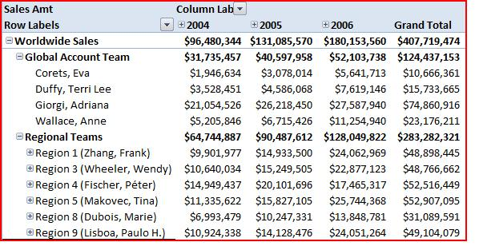

The benefit of using the pivot table view is it is used to combine and compare large amounts of data. Also the rows and columns can be rotated to summarize the data so in the end it can be used to analyze summarized totals.

1. Based on the information found in question #7, recommend a candidate for 2006 Regional Manager of the Year Award. Justify your selection in detail.

Tina Makovec would be the best candidate for the 2006 Regional Manager of the Year Award because he raised the most amount of money during the year of 2006.

1. Review the code sample below? What is it? What decision will likely be made as a result?

SELECT FIRST, LAST, ID FROM STUDENT_DATA WHERE TOT_GPA > 3.5 AND ASD_NUM = 0;

This is a query. As a result, it will only select First, Last, and ID columns from the table student_data. However, from those columns, it will only select the people where their GPA is greater than 3.5 and if their after school detention number is equal to 0.

1. Explain the difference between database reports and database forms.

Database reports are the output based on the information found in databases, tables or database queries. Forms however are different because you can put whatever you want on a form, including graphs, tables, and more. Forms are presented in a spreadsheet.